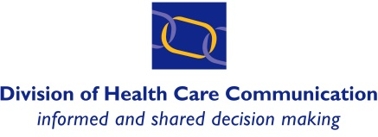
R. Paul Kerston Community Educator Award
Nomination Form
Deadline: March 31st
About the Nominee:
Full name of nominee (or lead if nominating a group: identify one person as lead):

If nominating a group, list other members in the group:

Address:

Telephone:

Email:

Role in education at UBC:

Community organization/affiliation (if applicable):

UBC program (if applicable):

Number of years working in partnership with UBC:

About the Nominator (nominator can be a student, faculty, staff, or community member)*
Full name of nominator:

Address:

Telephone:

Email:

Check one: UBC student UBC faculty UBC staff Community member

UBC program/department/unit (if applicable):

Community organization (if applicable):

*If the nominator is not a student, please attach at least one letter of support from a student.

A. Outline how the nominee has demonstrated the award criteria (max 1 page):
- It is important to provide as much information as possible about what the nominee has done that demonstrates the criteria (e.g. the number of students impacted, length of time, and nature of the impact on students).
- Refer to specific award criteria (e.g. instills values of interprofessional practice, patient-centred care, accessibility, lived experience, holistic learning, community engagement by students).
- The use of relevant examples and supporting evidence is encouraged (e.g. written description, testimony from witnesses, quotes from students, film, art work, supporting photos).
B. Provide additional information about how the nominee is deserving of this award (max 1 page):
- Provide any additional information that you have about how the nominee is deserving of this award and why you chose to nominate s/he/them.
- The use of relevant and specific examples is encouraged.

C. If the nominator is not a student, attach at least one letter of support from a student.

Return the completed nomination form to Cathy Kline by 4:30 PM on March 31st.
Email: cckline@mail.ubc.ca
Or
Mail: 400 – 2194 Health Sciences Mall, Vancouver, BC V6T 1Z3

Questions?
Contact Cathy Kline by phone 604-822-8002 or email cckline@mail.ubc.ca

Award(s) will be announced in June!

